Sales Force Account Setup
Version 1.0
December 21, 2014

Document Information
Category | Information
Customer
Project | HMIS
Document
Document Version | 1.0
Identifier
Author(s) | Ashaar Riaz
Approver(s)
Issue Date | December 21, 2014
Document Location
Distribution
Document Revision History
Author | Date | Version | Description(Change made, Sec Ref, CR#)
Ashaar Riaz | December 21, 2014 | 1.0 | SalesForce Account Setup

Definition of Terms, Acronyms and Abbreviations
This section should provide the definitions of all terms, acronyms, and abbreviations required to interpret these terms properly. This information may be provided by reference to the project Glossary.
Term | Description

List of Appendices
Appendix # | Appendix Name | Page #

Goal
The objective of this document is to describe the steps to setup an account on SalesForce.com. for OAuth2.0

Step 1 Sign up to SalesForce site
The first step is to sign up to the salesForce site.
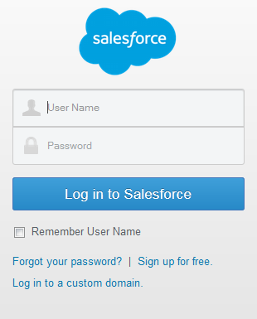
Fig.1.1 SalesForce Signup
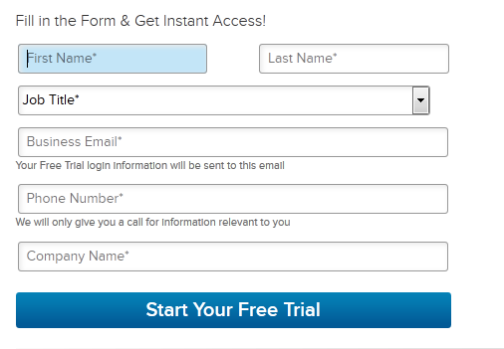
Fig.1.2
Once you sign up, you will get an email from sales force. Follow the email and activate your account. To access the OpenHMIS API, you need your sales force username, password and security token. If you don’t receive the security token when you sign up, you can reset it from salesforce site.

Step 2 Reset Security Token
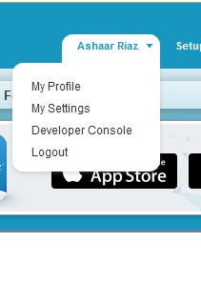
Fig.2.1 Account Setting
Click on the your name left to the setup, account setting page in the Fig.2.2 will appear.
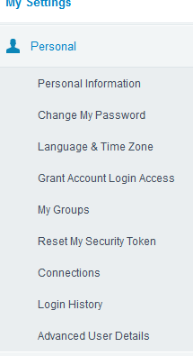
Fig.2.2 Personal Account Setting
Click on the “Reset My Security Token”, your security token will be refreshed and new security token will be send your email.

Now you have all the information to access the Open HMIS API. When you are access API, you need to send the username/password+securityToken along with the URL.
For example to access the Client information by ClientKey I am using the following URl
http://127.0.0.1:9080/OpenHMIS/services/clients/client/75864/ashaar.riaz@pcni.org/faiza3648BjGNCvnIComUhSVOczUks8g

My clientKey = 75864 (Client I want to search)
My username = ashaar.riaz@pcni.org
Mypassword+Security Token = faiza3648BjGNCvnIComUhSVOczUks8g

